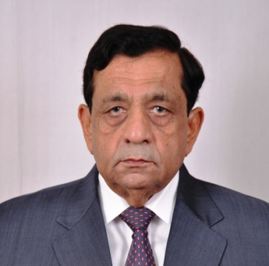

Mr. Nitin Desai is a Graduate in Civil Engineering and Masters in Environmental Engineering from the University of Michigan, Ann Arbor, USA.

He is the Chairman and Managing Director of Desai Brothers Limited, Pune, a leading corporate in the diversified business of manufacturing bidis and food products, finance and investments, hospitality and wind power generation.

He is also Chairman of Aquapharm Chemicals Pvt. Ltd., which is engaged in the business of specialty chemicals.

He is actively associated with the healthcare industry and is one of the Promoter Directors of the fast expanding “Sahyadri Hospitals Ltd”.

He is also actively involved with diverse social activities, mainly in the spheres of eye care, environment, support to the disabled and education.

He is the Chairman of the Poona Blind Mens’ Association and H. V. Desai Eye Hospital.  In recognition of his leading role in providing comprehensive eye care, he was felicitated by the former President of India, Dr. A.P.J. Abdul Kalam.

He is the President of Shri Poona Gujarati Bandhu Samaj, a social organization working for welfare of Gujarati community of Pune.

He has been a Trustee of Poona Gujarati Kelvani Mandal, a trust running various educational institutes in Pune.

He is also a Trustee of Vanarai, founded by Late Shri Mohan Dhariya, former Vice Chairman of the Planning Commission of India.

He has served as President of the prestigious Poona Club.  He was also President of Poona Junior Chamber and Vice – President of Indian Jaycees.

In appreciation of Mr. Desai’s  multifarious achievements and noteworthy contribution in the fields of business and social work, the Poona Merchants Chambers awarded Mr. Desai the “Adarsh Vayapari – Uttam Puraskar” in 2004.

He is also an Independent Director of Force Motors Ltd., Pune & Cadila Healthcare Ltd., Ahmedabad